Marc De La Cruz

MGMT 3000

02/10/19

Everest Summary and Review

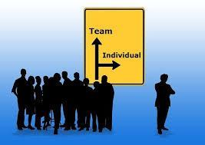**Team vs. Individual Goals**

When we first started the Everest simulation, I didn’t know what was expected of me as far as individual goals go. I knew that I would be expected to work together with my team and we were expected to summit to the peak of the mountain, but I wasn’t sure whether I would have to keep a daily log of all of our activities, make complex decisions throughout the journey, or anything of that nature, so I was a little worried about what was going to be expected of me. However, once the simulation was started, I saw that we were broken up into individual roles with individual agendas as well as team objectives that were somewhat compliant with our individual goals. Immediately it became apparent that there were some goals that needed to be completed, and others that were contradictive of each other. This is where communication and having a responsible team came in to play. We all decided which goals were imperative to accomplish and which goals we would have to leave alone. Thankfully, there weren’t any conflicts within our group, we were able to communicate effectively and have reasonable discussions about what goals were important and what goals we could let go of.

**The Everest Experience**

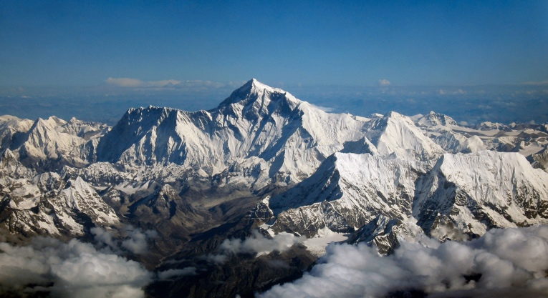The simulation itself wasn’t too difficult, each day we were given a specific objective that we had to accomplish, mine as the marathon runner, was to correctly predict the weather of the following day, if you were the physician, you were in charge of keeping everyone’s health at an optimal level, etc. Each person also had individual goals that they were in charge of, I was in charge of making sure I didn’t succumb to frostbite, the environmentalist wanted to make sure that camp 4 was clean, and the photographer wanted to get a picture at the peak of the mountain. As each day of the simulation unfolded, the team was tasked with new challenges, the first time we went through the simulation, the challenges were for lack of a better term, easy. The only challenge that was difficult was going through the simulation without any prior knowledge. We managed to do okay and get to camp 4 before having to be rescued. Going into the second run through the simulation, we were crunched for time, so we were making decisions at a faster rate which would have been okay if we were running through the exact same problems we ran into on the first run through. We encountered two difficult situations concerning a cut rope, and another concerning a weather warning throughout the mountain that was going to hinder us if we didn’t plan our trip accordingly. Unfortunately, because of a time crunch, confusion, and an overall scattered demeanor throughout the team, we didn’t reach the summit and had to be rescued by the Sherpas again.

**Conclusion**

In conclusion my team learned a lot about how to communicate effectively, prioritize objectives, specifically those concerning the team and those that are individual. Another important aspect of teamwork that we learned was how to operate under extreme time constraints. The second Everest simulation was truly a time crunch and it took a lot of teamwork and communication to even get on the same page so we wouldn’t have to be rescued straight out of the gate. Overall, the Everest simulation helped our teamwork and leadership skills grow and develop to help us improve them for behavioral management situations that will occur outside of the university.